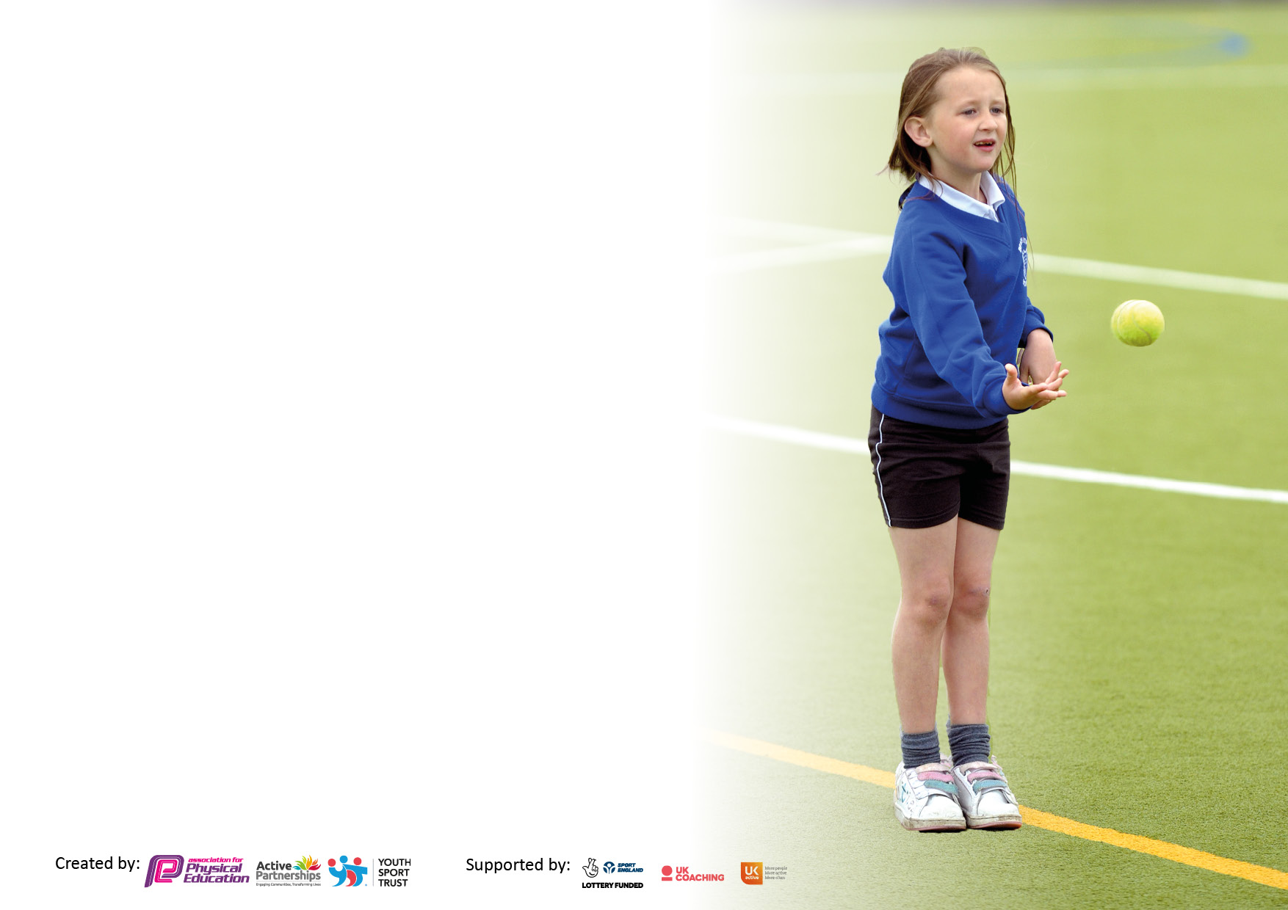

It is important that your grant is used effectively and based on school need. The Education Inspection Framework makes clear there will be a focus on **‘whether leaders and those responsible for governors all understand their respective roles and perform these in a way that enhances the effectiveness of the school’**.

Under the Quality of Education Ofsted inspectors consider:

**Intent** - Curriculum design, coverage and appropriateness

**Implementation** - Curriculum delivery, Teaching (pedagogy) and Assessment

**Impact** - Attainment and progress

To assist schools with common transferable language this template has been developed to utilise the same three headings which should make your plans easily transferable between working documents.

Schools must use the funding to make **additional and sustainable** improvements to the quality of Physical Education, School Sport and Physical Activity (PESSPA) they offer. This means that you should use the Primary PE and sport premium to:

* Develop or add to the PESSPA activities that your school already offer
* Build capacity and capability within the school to ensure that improvements made now will benefit pupils joining the school in future years
* The Primary PE and sport premium should not be used to fund capital spend projects; the school’s budget should fund these.

Pleasevisitgov.ukfortherevisedDfEguidanceincludingthe5keyindicatorsacrosswhichschoolsshoulddemonstrate animprovement.Thisdocumentwillhelpyoutoreviewyourprovisionandtoreportyourspend.DfEencouragesschools to use this template as an effective way of meeting the reporting requirements of the Primary PE and Sport Premium.

We recommend you start by reflecting on the impact of current provision and reviewing the previous spend.

Schools are required to publish details of how they spend this funding, including any under-spend from 2021/2022, as well as on the impact it has on pupils’ PE and sport participation and attainment. **All funding must be spent by 31st July 2023.**

We recommend regularly updating the table and publishing it on your website throughout the year. This evidences your ongoing self-evaluation of how you are using the funding to secure maximum, sustainable impact. Final copy must be posted on your website by the end of the academic year and no later than the 31st July 2023. To see an example of how to complete the table please click HERE.

**Details with regard to funding**

Please complete the table below.

|  |  |
| --- | --- |
| Total amount carried over from 2021/22 | £0 |
| Total amount allocated for 2021/22 | £ 19,400 |
| How much (if any) do you intend to carry over from this total fund into 2022/23? | £ 1,907.22 |
| Total amount allocated for 2022/23 | £19,400 |
| Total amount of funding for 2023/23. To be spent and reported on by 31st July 2023. | £ 21,307.22 |

**Swimming Data**

Please report on your Swimming Data below.

|  |  |
| --- | --- |
| Meeting national curriculum requirements for swimming and water safety.  N.B. Complete this section to your best ability. For example you might have practised safe self-rescue techniques on dry land which you can then transfer to the pool when school swimming restarts.  **Due to exceptional circumstances priority should be given to ensuring that pupils can perform safe self rescue even if they do not fully meet the first two requirements of the NC programme of study** |  |
| What percentage of your current Year 6 cohort swim competently, confidently and proficiently over a distance of at least 25 metres?  **N.B.** Even though your pupils may swim in another year please report on their attainment on leaving primary school at the end of the summer term 2023.  Please see note above | 90 % |
| What percentage of your current Year 6 cohort use a range of strokes effectively [for example, front crawl, backstroke and breaststroke]?  Please see note above | 90 % |
| **What percentage of your current Year 6 cohort perform safe self-rescue in different water-based situations?** | 55% |
| Schools can choose to use the Primary PE and sport premium to provide additional provision for swimming but this must be for activity **over and above** the national curriculum requirements. Have you used it in this way? | Yes/**No** |

**Action Plan and Budget Tracking**

Capture your intended annual spend against the 5 key indicators. Clarify the success criteria and evidence of impact that you intend to measure to evaluate for pupils today and for the future.

|  |  |  |  |  |
| --- | --- | --- | --- | --- |
| **Academic Year:** 2022/23 | **Total fund allocated:£19,400** | **Date Updated: 23.2.23** | |  |
| **Key indicator 1:** The engagement of all pupils in regular physical activity – Chief Medical Officers guidelines recommend that primary school pupils undertake at least 30 minutes of physical activity a day in school | | | | Percentage of total allocation: |
| 58% |
| **Intent** | **Implementation** | | **Impact** | £ 12,289 |
| Your school focus should be clear what you want the pupils to know and be able to do and about  what they need to learn and to  consolidate through practice: | Make sure your actions to achieve are linked to your intentions: | Funding allocated: | Evidence of impact: what do pupils now know and what can they now do? What has changed?: | Sustainability and suggested next steps: |
| * Access to GETSET4PE planning and resources for all staff to teach x 2 lessons a week as well as promoting active participation throughout the school day. * Sensory circuit club - daily for SEND children. * Access to high quality resources/equipment for lessons/afterschool clubs. * Access to training/lessons through specialist coaches. * LSSP Competition membership * Swimming/Top up swimming * Whole school approach to Daily mile * Socialising different year groups | * Audit of GETSET4PE payment * Audit of equipment and resources bought. * Different year groups have had access to a range of specialist coaches in different strands of sport/PE. * LSSP Membership paid. * Swimming/Top up swimming paid and implemented. * Daily mile is implemented by all year groups from nursery to Year 6 * Well-being warriors/play leaders. | £1375  £ 1783 (R)  £ 720 /Nike/LFC funding  £1,775 (LSSP)  £6636 (S) | * All teachers teach 2x PE lessons a week, with high quality resources. * New equipment to support learning e.g. Athletics * Children in UKS2 have joined clubs outside of school e.g. girls football/Liverpool Harriers. * As the children move up the school, they are aware of the daily mile, the benefits and its routine in day-to-day school life. * Pupil voice / staff voice help to ensure improvements and consistency. | * Outside agencies secured for next year. * Continue to audit resources for Autumn 23. * LSSP Membership paid for next academic year. |
| **Key indicator 2:** The profile of PESSPA being raised across the school as a tool for whole school improvement | | | | Percentage of total allocation: |
| 1.9% |
| **Intent** | **Implementation** | | **Impact** | £400 |
| Your school focus should be clear what you want the pupils to know and be able to do and about  what they need to learn and to  consolidate through practice: | Make sure your actions to achieve are linked to your intentions: | Funding allocated: | Evidence of impact: what do pupils now know and what can they now do? What has changed?: | Sustainability and suggested next steps: |
| * Enhance links - literacy and PE (specifically reading) * Pupil voice * Staff voice * PE Ambassadors - Whole school approach. * Schools game mark * Wellbeing week for the whole school with a PE and Sport focus day - Resources ordered. | * Author booked for Autumn ‘23 * Continuous pupil voice * Continuous staff voice * Whole school well-being week booked wb/ 19.6.23 | £300  £100 | * Improve links between PE and literacy. * Cross curricular links * School games mark helps to raise profile of PESSPA across our school community. * Children and staff aware of PE and mental health/well-being link. | * Evaluate visit of author and look to future projects. * Source other cross-curricular/year group links. * Continue pupil/staff voice. * Future well-being weeks tbc. |

|  |  |  |  |  |
| --- | --- | --- | --- | --- |
| **Key indicator 3:** Increased confidence, knowledge and skills of all staff in teaching PE and sport | | | | Percentage of total allocation: |
| % |
| **Intent** | **Implementation** | | **Impact** | £ |
| Your school focus should be clear | Make sure your actions to | Funding | Evidence of impact: what do | Sustainability and suggested |
| what you want the pupils to know | achieve are linked to your | allocated: | pupils now know and what | next steps: |
| and be able to do and about | intentions: |  | can they now do? What has |  |
| what they need to learn and to |  |  | changed?: |  |
| consolidate through practice: |  |  |  |  |
| * GETSET 4 PE – High quality teaching and learning. * CPD via GETSET4PE platform for all staff. * Staff Voice * Staff meetings * Specialist coaches- teacher to stay in lessons and observe. * LSSP Competitions – various staff to attend/support. | * All teachers have access to Getset4PE platform. * To consult staff voice audits and offer CPD. * Staff CPD through meetings. |  | * High quality teaching across the school. * CPD Zoom for Dance – sent out to staff. * PE discussed in staff meeting and next steps. * Variety of competitions attended for children of all abilities and ages. | * Continue to use GetSet4pe * Continue staff voice for future CPD. * Continue to discuss the future of PE in staff meetings. |
| **Key indicator 4:** Broader experience of a range of sports and activities offered to all pupils | | | | Percentage of total allocation: |
| 1.7% |
| **Intent** | **Implementation** | | **Impact** | £360 |
| Your school focus should be clear | Make sure your actions to | Funding | Evidence of impact: what do | Sustainability and suggested |
| what you want the pupils to know | achieve are linked to your | allocated: | pupils now know and what | next steps: |
| and be able to do and about | intentions: |  | can they now do? What has |  |
| what they need to learn and to |  |  | changed?: |  |
| consolidate through practice: |  |  |  |  |
| Additional achievements:   * Wide range of in-school and after school clubs. * To enter more inclusion festivals. (LSSP) * Outside agencies: LFC Foundation, Liverpool Harriers, * Top up swimming for y6. * Dance teacher – y6 Production | * Timetables for extra-curricular clubs available on our website. * Inclusion festivals booked and attended. * LFC Foundation to provide workshops/sessions which include tennis, funetics, female empowerment and athletics. * Liverpool Harriers have provided basic, advanced and mastery courses to our pupils. * Top up swimming completed – June’23. * Y6 production underway with dance choreographed and taught. | £360 (Dance) | * Wide variety of extra-curricular clubs for all key stages. * Workshops and sessions delivered to different year groups. * Y6 Top up swimming completed and all children that attended passed. * Dance opportunities outside of the curriculum for both boys and girls. | * Extra-curricular clubs discussed for next academic year. * Workshops booked with Liverpool Harriers. |

|  |  |  |  |  |
| --- | --- | --- | --- | --- |
| **Key indicator 5:** Increased participation in competitive sport | | | | Percentage of total allocation: |
| 1.7% |
| **Intent** | **Implementation** | | **Impact** | £360 |
| Your school focus should be clear | Make sure your actions to | Funding | Evidence of impact: what do | Sustainability and suggested |
| what you want the pupils to know | achieve are linked to your | allocated: | pupils now know and what | next steps: |
| and be able to do and about | intentions: |  | can they now do? What has |  |
| what they need to learn and to |  |  | changed?: |  |
| consolidate through practice: |  |  |  |  |
| * LSSP Competitions (both competitive and non-competitive.) * Catholic schools’ Athletics competition * Liverpool Cross country races * LFC Foundation events. * School sports day – support from Harriers coaches. | * Competitions entered and attended. * Athletics competition entered and complete. * Cross country club (Autumn and Spring term) – all races attended. * Increased participation in a variety of sports through link with LFC Foundation. * Whole school sports day planned. | £ 100 (CC)  £ 100 (A)  £ 160 (H) | * Athletics competition – increase in student participation. * Y6 girls are cross country champions. * Range of children across key stages participating in competitions. * Fitness levels have improved in our cross country club/races. | * LSSP Competition membership secured. * Cross country secured and club planned. |

|  |  |
| --- | --- |
| Signed off by | |
| Head Teacher: |  |
| Date: |  |
| Subject Leader: | R.Clarke and M.O’Shea |
| Date: | 26.6.23 |
| Governor: |  |
| Date: |  |